Week 15 Assessment – Northwind Catalog
Name : Upkaar Malik

- Solution structure
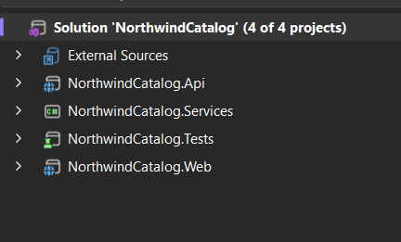

Step 1 - DB First
Entity Framework Core DB First approach was implemented using Scaffold-DbContext.

Command used in pmc
Scaffold-DbContext "Server=.\sqlexpress;Database=Northwind;Trusted_Connection=True;TrustServerCertificate=True;" Microsoft.EntityFrameworkCore.SqlServer -OutputDir Models -ContextDir Data -Context NorthwindContext -Tables Categories,Products -Force

Tables that were scaffolded:
- Categories
- Products

Step 2 - Fluent API
Fluent API configuration was added inside NorthwindContext.cs.
Implemented:
- UnitPrice column type as decimal(10,2)
- Product → Category relationship using Foreign Key
Example:
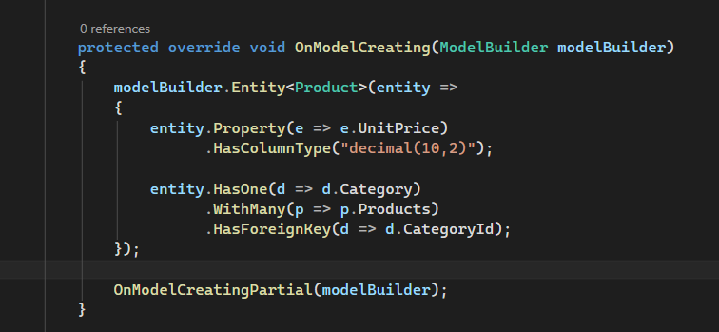

Step 3 - DTOs
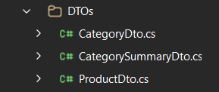

Step 4 - AutoMapper

AutoMapper was implemented using MappingProfile.cs.
Used for:
- Category → CategoryDto
- Product → ProductDto
Also added image mapping: /images/default.jpg

Step 5 - Repository Pattern
- Interfaces
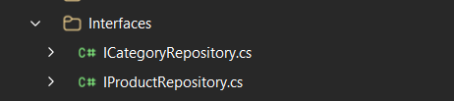
- Repositories
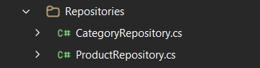

Step 6 - Web API
A separate API project NorthwindCatalog.Api was created.
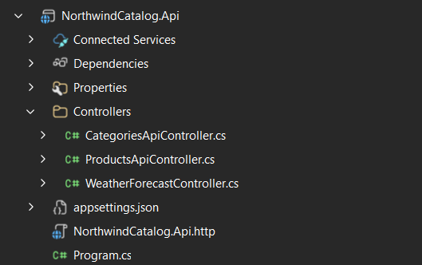

Step 7 - MVC
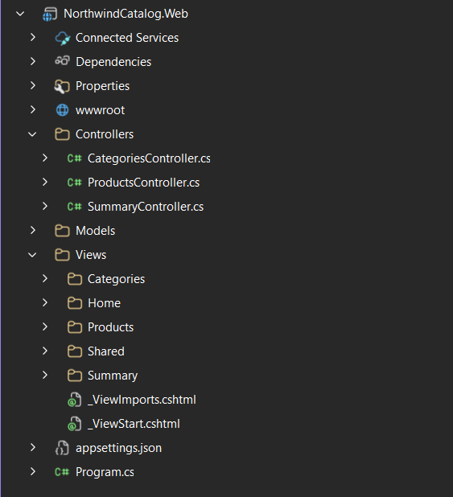
Step 8 - UI
Used bootstrap ui for all pages
Additional CSS to improve frontend

Step 9 - Unit Testing using xUnit
It was implemented inside NorthwindCatalog.Tests
Tests created:
- InventoryValue_Should_Return_Correct_Value()
- InventoryValue_Should_Return_Zero_When_Stock_Is_Zero()
- InventoryValue_Should_Return_Zero_When_UnitPrice_Is_Zero()

Final Project :
